***YSL Rouge Pur Couture The Slim***

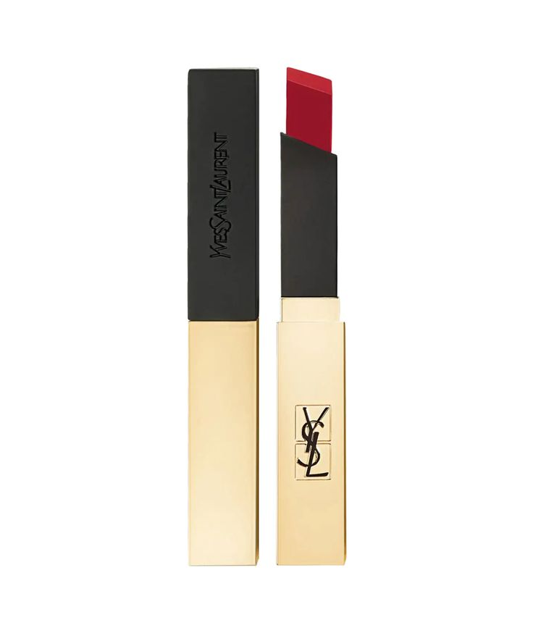

*YSL Rouge Pur Couture The Slim Lipstick has a slim, luxurious body with a golden shell. Silky smooth lipstick. Lightly on the lips with a thin, light surface. The lipstick has the ability to be super vibrant, lasts all day and does not dry the lips. (6 colors). Suitable as a gift for girls and women*